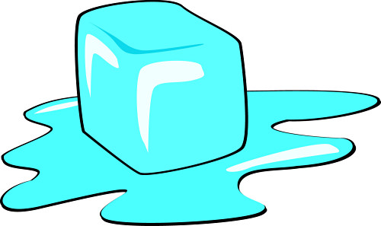
Apostrophe of Possession
Physical Change

Apostrophe of possession is used to show that the object belongs to someone or something. For example: Tom’s bicycle. The bicycle belongs to Tom. Or, the house’s roof needed repairing. The roof belongs to the house.

Choose the correct alternative:

1. A solids/solid’s particles are packed tightly/loosely together.

2. Solids/solid’s are incompressible/compressible and keep their/there shape.

3. A liquids/liquid’s particles are packed tightly/loosely together

4. A liquids/liquid’s particle are/is not stuck rigidly together and so they can flow and take on the shape of the container.

5. A gases/gas’s particles are not stuck together at all.

6. Gases/gas’s are highly compressible.

7. Gases/gas’s take the shape of the container they are in.

8. Melting is/are when a solids/solid’s particles move slightly apart and become a liquid.

9. Freezing is/are when a liquids/liquid’s particles move slightly closer and become a solid

10. Evaporation is/are when a liquids/liquid’s particles move slightly apart and become a gas.

11. Condensation is/are when a gases/gas’s particles move slightly closer and become a liquid.

Questions:

1. Describe the position of a solid’s particles __________________________________

2. Can a solid be compressed? ______________________________________________

3. Does the shape of a solid change? _________________________________________

4. Describe the position of a liquid’s particles _________________________________

5. Describe the shape of a liquid ____________________________________________

6. Can a liquid flow? _____________________________________________________

7. Describe the position of a gases particles ___________________________________

8. Can a gas be compressed? _______________________________________________

9. Describe the shape of a gas ______________________________________________

10. Describe melting ______________________________________________________

_____________________________________________________________________

11. Describe freezing ______________________________________________________

____________________________________________________________________

12. Describe evaporation ___________________________________________________

_____________________________________________________________________

13. Describe condensation __________________________________________________

_____________________________________________________________________



